**SQL HANDSON ASSESSMENT**

**Question-1**

__________________________________________________

CREATE TABLE Employees(

Employee_id INT PRIMARY KEY,

Name VARCHAR(100),

Position VARCHAR(100),

Salary INT

);

CREATE TABLE Employees_Audit(

Audit_id INT GENERATED BY DEFAULT AS IDENTITY PRIMARY KEY,

Employee_id INT,

Operation VARCHAR(10),

Change_date DATE,

Old_name VARCHAR(100),

Old_position VARCHAR(100),

Old_salary INT,

New_name VARCHAR(100),

New_position VARCHAR(100),

New_salary INT

)

CREATE OR REPLACE FUNCTION Employees_Audit_Trigger()

RETURNS TRIGGER AS $$

BEGIN

IF TG_OP = 'INSERT' THEN

INSERT INTO Employees_Audit (

Employee_id, Operation, Change_date,

Old_name, Old_position, Old_salary,

New_name, New_position, New_salary

) VALUES (

NEW.Employee_id,

TG_OP,

CURRENT_DATE,

NULL, NULL, NULL, -- No old values on INSERT

NEW.Name, NEW.Position, NEW.Salary

);

ELSIF TG_OP = 'UPDATE' THEN

INSERT INTO Employees_Audit (

Employee_id, Operation, Change_date,

Old_name, Old_position, Old_salary,

New_name, New_position, New_salary

) VALUES (

NEW.Employee_id,

TG_OP,

CURRENT_DATE,

OLD.Name, OLD.Position, OLD.Salary,

NEW.Name, NEW.Position, NEW.Salary

);

ELSIF TG_OP = 'DELETE' THEN

INSERT INTO Employees_Audit (

Employee_id, Operation, Change_date,

Old_name, Old_position, Old_salary,

New_name, New_position, New_salary

) VALUES (

OLD.Employee_id,

TG_OP,

CURRENT_DATE,

OLD.Name, OLD.Position, OLD.Salary,

NULL, NULL, NULL -- No new values on DELETE

);

END IF;

RETURN NEW;

END;

$$ LANGUAGE plpgsql;

CREATE TRIGGER employee_trigger

AFTER INSERT OR UPDATE OR DELETE on Employees

FOR EACH ROW

EXECUTE PROCEDURE Employees_Audit_Trigger();

-- Insert Queries

INSERT INTO Employees VALUES(1, 'Vivek', 'CEO', 690000);

INSERT INTO Employees VALUES(2, 'Vinay', 'CTO', 29000);

INSERT INTO Employees VALUES(3, 'Manju', 'HR', 10000);

INSERT INTO Employees VALUES(4, 'Manoj', 'IT', 20000);

-- Update Queries

UPDATE Employees SET Position='Finance' WHERE Employee_id=4;

UPDATE Employees SET Salary=43000 WHERE Employee_id=3;

-- DELETE Queries

DELETE FROM Employees WHERE Employee_id=4;

-- Viewing the Audit Logs

SELECT * FROM Employees_Audit;

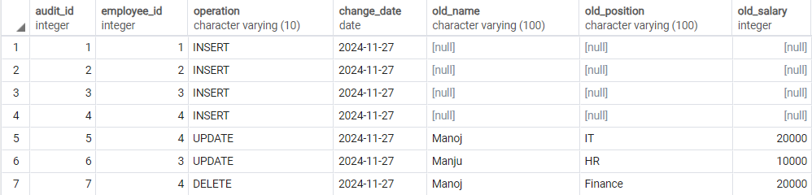

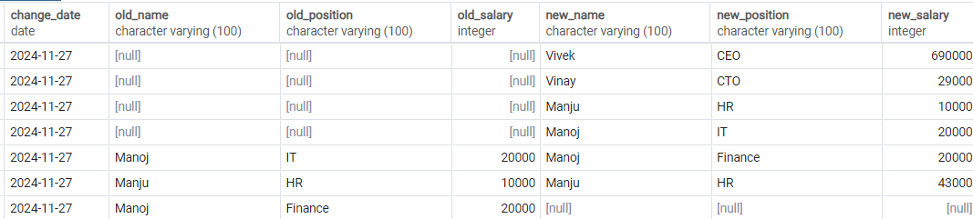

**Question-2**

__________________________________________________

CREATE TABLE Orders(

Order_id INT PRIMARY KEY,

Customer_id INT,

Order_Date DATE,

Status VARCHAR(50),

Total_Amount INT

);

-- FUNCTION TO CHANGE AND UPDATE PRODUCT STATUS BASED ON THE VALUES PROVIDED

CREATE OR REPLACE FUNCTION Order_Status_Update(

P_Order_id INT,

Payment_Received BOOLEAN,

Shipment_Made BOOLEAN,

Delivery_Confirmed BOOLEAN

) RETURNS VOID

LANGUAGE plpgsql

AS $$

DECLARE

Current_Status VARCHAR(50);

P_Order_Date DATE;

BEGIN

IF NOT EXISTS (SELECT 1 FROM Orders WHERE Order_id = P_Order_id) THEN

RAISE NOTICE 'Order with ID % does not exist.', Order_id;

RETURN;

END IF;

SELECT Status, Order_date INTO Current_Status, P_Order_Date FROM Orders WHERE Order_id = P_Order_id;

IF Current_Status = 'Pending' AND Payment_Received THEN

UPDATE Orders SET Status = 'Processed' WHERE Order_id = P_Order_id;

RAISE NOTICE 'Order status updated to Processed.';

ELSIF Current_Status = 'Processed' AND Shipment_Made THEN

UPDATE Orders SET Status = 'Shipped' WHERE Order_id = P_Order_id;

RAISE NOTICE 'Order status updated to Shipped.';

ELSIF Current_Status = 'Shipped' AND Delivery_Confirmed THEN

UPDATE Orders SET Status = 'Delivered' WHERE Order_id = P_Order_id;

RAISE NOTICE 'Order status updated to Delivered.';

ELSIF Current_Status = 'Pending' AND CURRENT_DATE - P_Order_Date > 7 THEN

UPDATE Orders SET Status = 'Cancelled' WHERE Order_id = P_Order_id;

RAISE NOTICE 'Order status updated to Cancelled due to overdue.';

ELSE

RAISE NOTICE 'No Status Change Required for Order %.', P_Order_id;

END IF;

END;

$$;

-- INSERT QUERIES

INSERT INTO Orders (Order_id, Customer_id, Order_Date, Status, Total_Amount)

VALUES (1, 101, '2024-11-25', 'Pending', 1500);

INSERT INTO Orders (Order_id, Customer_id, Order_Date, Status, Total_Amount)

VALUES (2, 102, '2024-11-24', 'Processed', 2500);

INSERT INTO Orders (Order_id, Customer_id, Order_Date, Status, Total_Amount)

VALUES (3, 103, '2024-11-23', 'Shipped', 2000);

INSERT INTO Orders (Order_id, Customer_id, Order_Date, Status, Total_Amount)

VALUES (4, 104, '2024-11-21', 'Delivered', 3000);

INSERT INTO Orders (Order_id, Customer_id, Order_Date, Status, Total_Amount)

VALUES (5, 105, '2024-11-25', 'Pending', 1200);

INSERT INTO Orders (Order_id, Customer_id, Order_Date, Status, Total_Amount)

VALUES (6, 106, '2024-11-10', 'Pending', 1800);

-- Operations

SELECT Order_Status_Update(1, TRUE, FALSE, FALSE) -- Status changed to Processed

SELECT Order_Status_Update(1, TRUE, TRUE, FALSE) -- Status changed to Shipped

SELECT Order_Status_Update(1, TRUE, TRUE, TRUE) -- Status changed to Processed

SELECT Order_Status_Update(6, FALSE, FALSE, FALSE)

-- Viewing the orders

SELECT * FROM Orders;

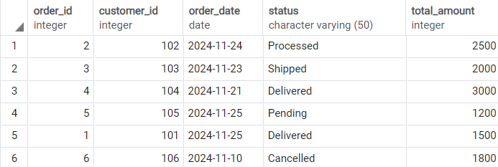

**Question-3**

__________________________________________________

CREATE TABLE Students(

Student_id INT PRIMARY KEY,

Name VARCHAR(100),

Score INT

)

-- INSERT QUERIES

INSERT INTO Students (Student_id, Name, Score)

VALUES (1, 'Alice', 85);

INSERT INTO Students (Student_id, Name, Score)

VALUES (2, 'Bob', 92);

INSERT INTO Students (Student_id, Name, Score)

VALUES (3, 'Charlie', 78);

INSERT INTO Students (Student_id, Name, Score)

VALUES (4, 'David', 88);

INSERT INTO Students (Student_id, Name, Score)

VALUES (5, 'Eva', 95);

INSERT INTO Students (Student_id, Name, Score)

VALUES (6, 'Frank', 80);

INSERT INTO Students (Student_id, Name, Score)

VALUES (7, 'Grace', 91);

INSERT INTO Students (Student_id, Name, Score)

VALUES (8, 'Hannah', 74);

INSERT INTO Students (Student_id, Name, Score)

VALUES (9, 'Ivy', 89);

INSERT INTO Students (Student_id, Name, Score)

VALUES (10, 'Jack', 82);

SELECT * FROM Students

-- PROCEDURE PART

CREATE OR REPLACE FUNCTION Student_Grade()

RETURNS VOID as $$

DECLARE

record Students%ROWTYPE;

BEGIN

ALTER TABLE Students ADD COLUMN Grade VARCHAR(50);

ALTER TABLE Students ADD COLUMN Remarks VARCHAR(50);

FOR record in (SELECT * FROM Students)

LOOP

UPDATE Students

SET Grade =

CASE

WHEN Score >= 90 THEN 'A'

WHEN Score BETWEEN 80 AND 89 THEN 'B'

WHEN Score BETWEEN 70 AND 79 THEN 'C'

WHEN Score BETWEEN 60 AND 69 THEN 'D'

ELSE 'F'

END,

Remarks =

CASE

WHEN Score >= 90 THEN 'Excellent'

WHEN Score BETWEEN 80 AND 89 THEN 'Good Job'

WHEN Score BETWEEN 70 and 79 THEN 'Fair Effort'

WHEN Score < 60 THEN 'Needs Improvement'

ELSE ''

END

WHERE Student_id = record.Student_id;

END LOOP;

END;

$$ LANGUAGE plpgsql;

SELECT Student_Grade();

SELECT * FROM Students

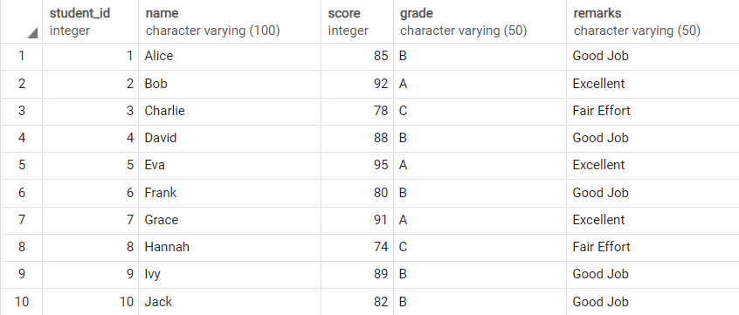

**Question-4**

__________________________________________________

CREATE TABLE Students_2(

Student_id INT PRIMARY KEY,

Name VARCHAR(100),

Score INT

);

CREATE TABLE audit_log (

log_id INT PRIMARY KEY,

student_id INT,

log_message VARCHAR(255),

log_date DATE

);

CREATE SEQUENCE audit_log_seq

START WITH 1

INCREMENT BY 1

NO CYCLE;

-- INSERT QUERIES

-- INSERT QUERIES

INSERT INTO Students_2 (Student_id, Name, Score)

VALUES (1, 'Alice', 85);

INSERT INTO Students_2 (Student_id, Name, Score)

VALUES (2, 'Bob', 92);

INSERT INTO Students_2 (Student_id, Name, Score)

VALUES (3, 'Charlie', 78);

INSERT INTO Students_2 (Student_id, Name, Score)

VALUES (4, 'David', 70);

INSERT INTO Students_2 (Student_id, Name, Score)

VALUES (5, 'Eva', 68);

INSERT INTO Students_2 (Student_id, Name, Score)

VALUES (6, 'Frank', 80);

INSERT INTO Students_2 (Student_id, Name, Score)

VALUES (7, 'Grace', 21);

INSERT INTO Students_2 (Student_id, Name, Score)

VALUES (8, 'Hannah', 74);

INSERT INTO Students_2 (Student_id, Name, Score)

VALUES (9, 'Ivy', 89);

INSERT INTO Students_2 (Student_id, Name, Score)

VALUES (10, 'Jack', 43);

-- CREATING THE PROCEDURE

ALTER TABLE Students_2 ADD COLUMN Grade VARCHAR(50);

CREATE OR REPLACE FUNCTION Student_Grade_Log()

RETURNS VOID AS $$

DECLARE

rec RECORD;

s_grade VARCHAR(2);

s_log VARCHAR(100);

BEGIN

FOR rec in (SELECT * FROM Students_2)

LOOP

IF rec.Score >= 90 THEN

s_grade := 'A';

ELSIF rec.Score BETWEEN 80 AND 89 THEN

s_grade := 'B';

ELSIF rec.Score BETWEEN 70 AND 79 THEN

s_grade := 'C';

ELSIF rec.Score BETWEEN 60 AND 69 THEN

s_grade := 'D';

ELSE

s_grade := 'F';

END IF;

UPDATE Students_2 SET Grade = s_grade WHERE Student_id = rec.Student_id;

s_log := 'Student with ID ' || rec.Student_id || ' assigned Grade: ' || s_grade;

INSERT INTO audit_log(

log_id, student_id, log_message, log_date

) VALUES(

NEXTVAL('audit_log_seq'), rec.Student_id, s_log, CURRENT_DATE

);

END LOOP;

END;

$$ LANGUAGE plpgsql;

SELECT Student_Grade_Log();

SELECT * FROM Students_2;

SELECT * FROM audit_log;

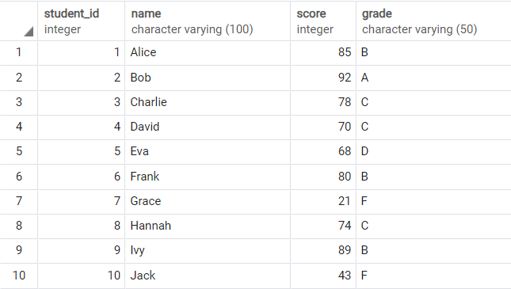

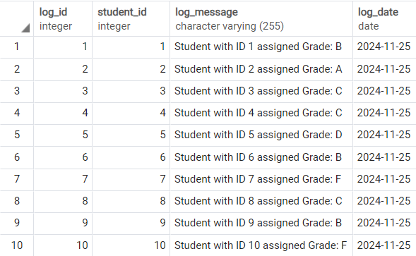

**Question-5**

__________________________________________________

CREATE TABLE Orders_2(

Order_id INT PRIMARY KEY,

Customer_id INT,

Order_Date DATE,

Total_Amount NUMERIC(10, 2),

Discounted_Amount NUMERIC(10, 2)

);

INSERT INTO Orders_2 (Order_id, Customer_id, Order_Date, Total_Amount)

VALUES (1, 101, '2024-11-25', 700);

INSERT INTO Orders_2 (Order_id, Customer_id, Order_Date, Total_Amount)

VALUES (2, 102, '2024-11-20', 300);

INSERT INTO Orders_2 (Order_id, Customer_id, Order_Date, Total_Amount)

VALUES (3, 103, '2024-11-25', 200);

INSERT INTO Orders_2 (Order_id, Customer_id, Order_Date, Total_Amount)

VALUES (4, 104, '2024-11-20', 499.99);

INSERT INTO Orders_2 (Order_id, Customer_id, Order_Date, Total_Amount)

VALUES (5, 105, '2024-11-10', 199.99);

select * from Orders_2

-- PROCEDURE PART

CREATE OR REPLACE FUNCTION Order_Discount()

RETURNS VOID AS $$

DECLARE

order_count INT;

order_no INT;

discount NUMERIC(10, 2);

total_amt NUMERIC(10, 2);

BEGIN

SELECT COUNT(*) INTO order_count FROM Orders_2;

order_no := 1;

WHILE order_no <= order_count

LOOP

SELECT Total_Amount into total_amt FROM Orders_2 WHERE Order_id=order_no;

UPDATE Orders_2

SET Discounted_Amount =

CASE

WHEN total_amt >= 500 THEN total_amt - 0.2 * total_amt

WHEN total_amt BETWEEN 200 AND 499.99 THEN total_amt - 0.1 * total_amt

WHEN total_amt < 200 THEN total_amt

END

WHERE Order_id = order_no;

order_no := order_no + 1;

END LOOP;

END;

$$ LANGUAGE plpgsql

SELECT Order_Discount();

select * from Orders_2

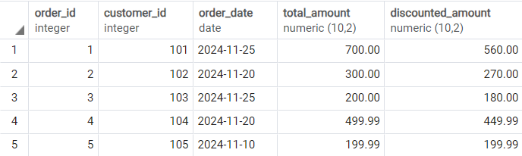

**Question-6**

__________________________________________________

CREATE TABLE Employees_2(

EmployeeID INT PRIMARY KEY,

Name VARCHAR(100),

Status VARCHAR(50)

);

INSERT INTO Employees_2 VALUES(1, 'Vivek', 'Active');

INSERT INTO Employees_2 VALUES(2, 'Vinay', 'Active');

INSERT INTO Employees_2 VALUES(3, 'Manju', 'On Leave');

INSERT INTO Employees_2 VALUES(4, 'Manoj', 'Resigned');

INSERT INTO Employees_2 VALUES(5, 'Jake', 'Active');

INSERT INTO Employees_2 VALUES(6, 'Logan', 'On Leave');

INSERT INTO Employees_2 VALUES(7, 'Josh', 'Active');

SELECT * FROM Employees_2;

DO $$

DECLARE

rec Record;

BEGIN

FOR rec in (SELECT * FROM Employees_2)

LOOP

IF rec.Status = 'On Leave' THEN

CONTINUE;

ELSE

RAISE NOTICE 'Employee: % | Status: %', rec.Name, rec.Status;

END IF;

END LOOP;

END;

$$ LANGUAGE plpgsql;

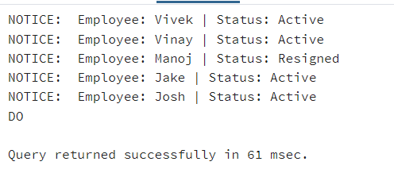

**Question-7**

__________________________________________________

CREATE TABLE Employees_3(

Employee_id INT PRIMARY KEY,

First_Name VARCHAR(50),

Last_Name VARCHAR(50),

Salary NUMERIC(10, 2),

Performance_Rating INT CHECK(Performance_Rating BETWEEN 1 AND 5)

);

CREATE TABLE Salary_Adjustments(

Rating INT,

Adjustment_Percentage INT

);

INSERT INTO Salary_Adjustments VALUES (5, 20), (4, 10), (3, 5), (2, 0), (1, -5);

SELECT * FROM Salary_Adjustments;

INSERT INTO Employees_3 VALUES(1, 'Vivek', 'Nair', 45000, 5);

INSERT INTO Employees_3 VALUES(2, 'Vinay', 'Nair', 15000, 1);

INSERT INTO Employees_3 VALUES(3, 'Jake', 'Paul', 6200, 4);

INSERT INTO Employees_3 VALUES(4, 'Logan', 'Paul', 68000, 3);

INSERT INTO Employees_3 VALUES(5, 'Linkin', 'Park', 32000, 2);

INSERT INTO Employees_3 VALUES(6, 'Bruno', 'Mars', 73000, 1);

INSERT INTO Employees_3 VALUES(7, 'John', 'Doe', 85000, 4);

INSERT INTO Employees_3 VALUES(8, 'Josh', 'Rich', 21000, 3);

SELECT * FROM Employees_3;

-- PROCEDURE CREATION

CREATE OR REPLACE FUNCTION Employee_Salary_Adjustments()

RETURNS VOID AS $$

DECLARE

emp_rating INT;

salary_diff NUMERIC(10, 2);

rec RECORD;

BEGIN

FOR rec in (SELECT * FROM Employees_3)

LOOP

SELECT Adjustment_Percentage/100.0 INTO salary_diff FROM Salary_Adjustments

WHERE Rating = rec.Performance_Rating;

UPDATE Employees_3

SET Salary = Salary + salary_diff * Salary

WHERE Employee_id = rec.Employee_id;

END LOOP;

END;

$$ LANGUAGE plpgsql;

SELECT * FROM Employee_Salary_Adjustments();

SELECT * FROM Employees_3;

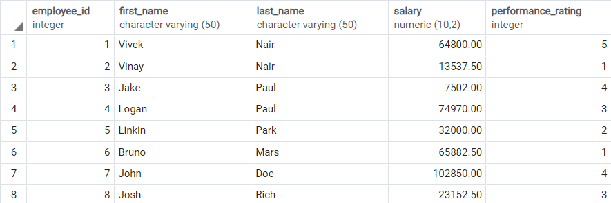

**Question-8**

__________________________________________________

CREATE TABLE Performance_Rating(

Rating INT,

Bonus_Percentage INT

);

INSERT INTO Performance_Rating VALUES (5, 25), (4, 15), (3, 10), (2, 5), (1, 0);

-- Here we are referring to the Employee_3 Table for Bonus Calculation

SELECT * FROM Employees_3;

CREATE OR REPLACE FUNCTION Employee_Bonus(

Emp_ID INT

) RETURNS DECIMAL as $$

DECLARE

bonus DECIMAL(10, 2);

emp_rating INT;

BEGIN

SELECT Performance_Rating INTO emp_rating FROM Employees_3 WHERE Employee_id = Emp_ID;

bonus := (SELECT Bonus_Percentage FROM Performance_Rating WHERE Rating = emp_rating) / 100.0 *

(SELECT salary FROM Employees_3 WHERE Employee_id = Emp_ID);

RETURN bonus;

END;

$$ LANGUAGE plpgsql

-- Calling the function with corresponding Employee ID whose bonus is to be found

SELECT * FROM Employee_Bonus(1);

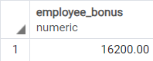

**Question-9**

__________________________________________________

CREATE TABLE Orders_3 (

order_id INT PRIMARY KEY,

customer_id INT,

order_date DATE

);

CREATE TABLE Order_Items (

order_id INT,

item_id INT,

quantity INT,

PRIMARY KEY (order_id, item_id)

);

CREATE TABLE Inventory (

item_id INT PRIMARY KEY,

item_name VARCHAR(100),

stock_level INT,

price NUMERIC(10, 2)

);

CREATE TABLE Order_Logs (

log_id INT PRIMARY KEY,

order_id INT,

log_message VARCHAR(255),

log_date DATE

);

CREATE SEQUENCE order_logs_seq

START WITH 1

INCREMENT BY 1

NO CYCLE;

-- Creation of Procedure Part

CREATE OR REPLACE FUNCTION Process_Customer_Order(p_order_id INT)

RETURNS VOID as $$

DECLARE

rec RECORD;

p_item_id INT;

p_quantity INT;

p_stock_level INT;

p_price NUMERIC(10, 2);

p_total_price NUMERIC(10, 2) := 0;

p_order_exists BOOLEAN;

BEGIN

SELECT EXISTS (SELECT 1 FROM Orders_3 WHERE Order_Id = p_order_id)

INTO p_order_exists;

IF NOT p_order_exists THEN

RAISE EXCEPTION 'Invalid Order ID: %', p_order_id;

END IF;

FOR rec in (SELECT * FROM Order_Items WHERE order_id = p_order_id)

LOOP

p_item_id:= rec.item_id;

p_quantity := rec.quantity;

SELECT stock_level, price into p_stock_level, p_price

FROM Inventory

WHERE item_id = p_item_id;

IF p_stock_level < p_quantity THEN

RAISE EXCEPTION 'Insufficient stock for item ID: %', p_item_id;

END IF;

UPDATE Inventory

SET stock_level = stock_level - p_quantity

WHERE item_id = p_item_id;

p_total_price := p_total_price + (p_quantity * p_price);

END LOOP;

INSERT INTO Order_Logs VALUES(

NEXTVAL('order_logs_seq'),

p_order_id,

'Order processed successfully. Total Value: ' || p_total_price,

CURRENT_DATE

);

RAISE NOTICE 'Order processed successfully. Total Value: %', p_total_price;

EXCEPTION

WHEN OTHERS THEN

INSERT INTO order_logs

VALUES (NEXTVAL('order_logs_seq'), p_order_id, 'Error processing order: ' || SQLERRM, CURRENT_DATE);

RAISE NOTICE 'Error processing order ID %: %', p_order_id, SQLERRM;

END;

$$ LANGUAGE plpgsql;

-- Inserting sample orders

INSERT INTO orders_3 VALUES (1, 1, CURRENT_DATE);

INSERT INTO orders_3 VALUES (2, 2, CURRENT_DATE);

-- Inserting sample order items

INSERT INTO order_items (order_id, item_id, quantity) VALUES (1, 101, 2);

INSERT INTO order_items (order_id, item_id, quantity) VALUES (1, 102, 1);

INSERT INTO order_items (order_id, item_id, quantity) VALUES (2, 101, 5);

INSERT INTO order_items (order_id, item_id, quantity) VALUES (2, 102, 3);

-- Inserting sample inventory

INSERT INTO inventory (item_id, item_name, stock_level, price) VALUES (101, 'Item A', 10, 20.00);

INSERT INTO inventory (item_id, item_name, stock_level, price) VALUES (102, 'Item B', 5, 15.00);

SELECT * FROM Orders_3;

SELECT * FROM Order_Items;

SELECT * FROM Inventory;

SELECT Process_Customer_Order(2);

SELECT * FROM Order_Logs;

Orders

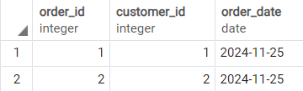

Order_Items

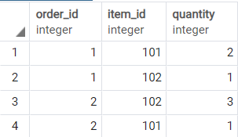

Inventory

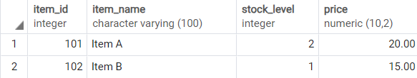

Order_Logs

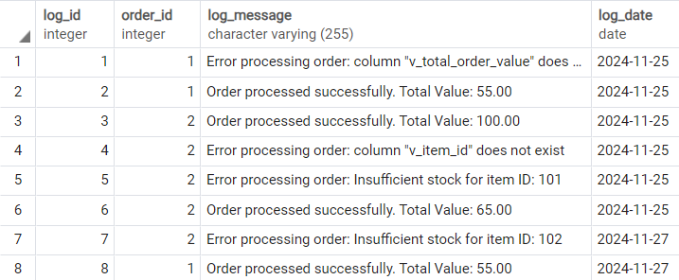

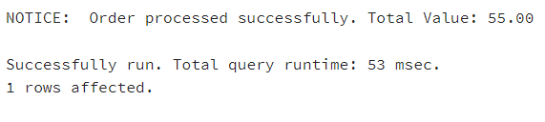

**Question-10**

__________________________________________________

CREATE OR REPLACE FUNCTION update_employee_salary(

emp_id INT,

new_salary NUMERIC

) RETURNS VOID AS

$$

DECLARE

v_current_salary NUMERIC;

min_salary_threshold NUMERIC;

BEGIN

SELECT salary

INTO v_current_salary

FROM Employee_4

WHERE employee_id = emp_id;

IF NOT FOUND THEN

RAISE EXCEPTION 'Error: Employee with ID % not found.', emp_id;

END IF;

IF new_salary < min_salary_threshold THEN

RAISE EXCEPTION 'Error: The new salary % is below the minimum allowed threshold of %.', new_salary, min_salary_threshold;

END IF;

UPDATE Employee_4

SET salary = new_salary

WHERE employee_id = emp_id;

RAISE NOTICE 'Employee salary updated successfully to %.', new_salary;

END;

$$ LANGUAGE plpgsql;

SELECT update_employee_salary(4, 55000);

SELECT update_employee_salary(8, 55000);

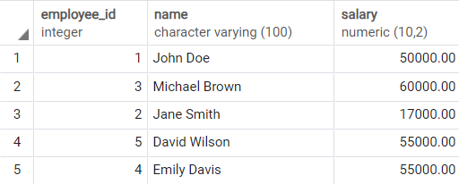

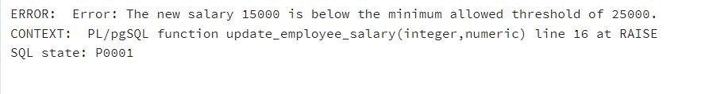

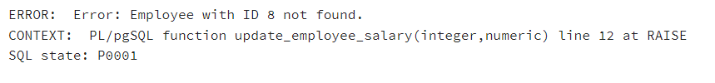

**Question-11**

__________________________________________________

CREATE TABLE departments (

department_id INT PRIMARY KEY,

department_name VARCHAR(100)

);

CREATE TABLE employees_5 (

employee_id INT PRIMARY KEY,

name VARCHAR(100),

department_id INT,

salary NUMERIC

);

INSERT INTO departments (department_id, department_name) VALUES (1, 'Human Resources');

INSERT INTO departments (department_id, department_name) VALUES (2, 'Finance');

INSERT INTO departments (department_id, department_name) VALUES (3, 'IT');

INSERT INTO departments (department_id, department_name) VALUES (4, 'Marketing');

INSERT INTO departments (department_id, department_name) VALUES (5, 'Operations');

INSERT INTO employees_5 (employee_id, name, department_id, salary) VALUES (1, 'Alice', 1, 60000);

INSERT INTO employees_5 (employee_id, name, department_id, salary) VALUES (2, 'Bob', 2, 75000);

INSERT INTO employees_5 (employee_id, name, department_id, salary) VALUES (3, 'Charlie', 3, 80000);

INSERT INTO employees_5 (employee_id, name, department_id, salary) VALUES (4, 'Diana', 4, 50000);

INSERT INTO employees_5 (employee_id, name, department_id, salary) VALUES (5, 'Ethan', 5, 70000);

INSERT INTO employees_5 (employee_id, name, department_id, salary) VALUES (6, 'Fiona', 3, 85000);

INSERT INTO employees_5 (employee_id, name, department_id, salary) VALUES (7, 'George', 2, 62000);

INSERT INTO employees_5 (employee_id, name, department_id, salary) VALUES (8, 'Hannah', 4, 58000);

INSERT INTO employees_5 (employee_id, name, department_id, salary) VALUES (9, 'Ian', 1, 63000);

INSERT INTO employees_5 (employee_id, name, department_id, salary) VALUES (10, 'Julia', 5, 69000);

DO $$

DECLARE

rec RECORD;

total_salary NUMERIC;

BEGIN

FOR rec in (SELECT * FROM departments)

LOOP

SELECT COALESCE(SUM(salary), 0)

INTO total_salary

FROM employees_5

WHERE department_id = rec.department_id;

RAISE NOTICE 'Department: % -- Total Salary: %',rec.department_name, total_salary;

END LOOP;

END;

$$ LANGUAGE plpgsql;

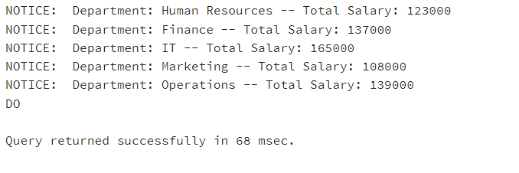

**Question-12**

__________________________________________________

-- Here we are referring to the Employee_3 and Performance_Rating Table for Bonus Calculation

SELECT * FROM Employees_3;

SELECT * FROM Performance_Rating;

CREATE OR REPLACE FUNCTION Employee_Bonus_Procedure()

RETURNS VOID as $$

DECLARE

rec RECORD;

bonus DECIMAL(10, 2);

emp_rating INT;

BEGIN

FOR rec IN (SELECT * FROM Employees_3)

LOOP

bonus := rec.salary * (select bonus_percentage FROM Performance_Rating

WHERE rating = rec.performance_rating)/100;

RAISE NOTICE 'Employee: % Salary: Rs. % Bonus: Rs. %',rec.first_name,rec.salary,bonus;

END LOOP;

END;

$$ LANGUAGE plpgsql

-- Calling the function with corresponding Employee ID whose bonus is to be found

SELECT * FROM Employee_Bonus_Procedure();

Employees_3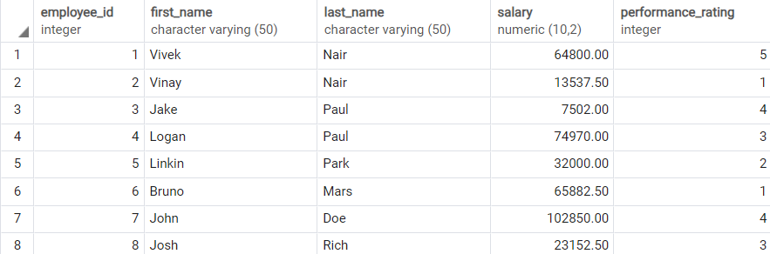

Performance_Rating

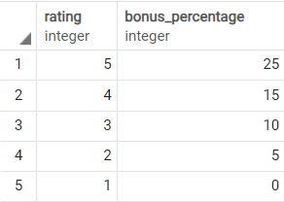

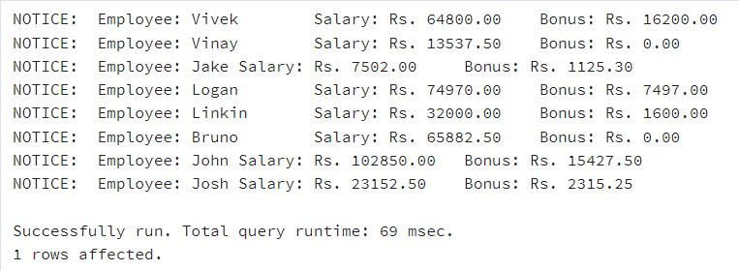

**Question-13**

__________________________________________________

CREATE TABLE EMPLOYEES (

Employee_id NUMBER PRIMARY KEY,

First_Name VARCHAR2(100),

Last_Name VARCHAR2(100),

Hire_date DATE,

Salary NUMBER(10, 2),

Department_id NUMBER

);

-- Create the package specification

CREATE OR REPLACE PACKAGE employee_mgmt_pkg AS

-- Procedure to add a new employee

PROCEDURE add_employee(

p_employee_id IN EMPLOYEES.Employee_id%TYPE,

p_first_name IN EMPLOYEES.First_Name%TYPE,

p_last_name IN EMPLOYEES.Last_Name%TYPE,

p_hire_date IN EMPLOYEES.Hire_date%TYPE,

p_salary IN EMPLOYEES.Salary%TYPE,

p_department_id IN EMPLOYEES.Department_id%TYPE

);

-- Procedure to update employee salary

PROCEDURE update_employee(

p_employee_id IN EMPLOYEES.Employee_id%TYPE,

p_salary IN EMPLOYEES.Salary%TYPE

);

-- Function to retrieve employee details

FUNCTION get_employee_details(

p_employee_id IN EMPLOYEES.Employee_id%TYPE

) RETURN EMPLOYEES%ROWTYPE;

END employee_mgmt_pkg;

/

-- Create the package body

CREATE OR REPLACE PACKAGE BODY employee_mgmt_pkg AS

-- Procedure to add a new employee

PROCEDURE add_employee(

p_employee_id IN EMPLOYEES.Employee_id%TYPE,

p_first_name IN EMPLOYEES.First_Name%TYPE,

p_last_name IN EMPLOYEES.Last_Name%TYPE,

p_hire_date IN EMPLOYEES.Hire_date%TYPE,

p_salary IN EMPLOYEES.Salary%TYPE,

p_department_id IN EMPLOYEES.Department_id%TYPE

) IS

BEGIN

INSERT INTO EMPLOYEES

VALUES (p_employee_id, p_first_name, p_last_name, p_hire_date, p_salary, p_department_id);

DBMS_OUTPUT.PUT_LINE('Employee added successfully.');

END add_employee;

-- Procedure to update employee salary

PROCEDURE update_employee(

p_employee_id IN EMPLOYEES.Employee_id%TYPE,

p_salary IN EMPLOYEES.Salary%TYPE

) IS

BEGIN

UPDATE EMPLOYEES

SET Salary = p_salary

WHERE Employee_id = p_employee_id;

IF SQL%ROWCOUNT = 0 THEN

DBMS_OUTPUT.PUT_LINE('No employee found with the given ID.');

ELSE

DBMS_OUTPUT.PUT_LINE('Employee salary updated successfully.');

END IF;

END update_employee;

-- Function to retrieve employee details

FUNCTION get_employee_details(

p_employee_id IN EMPLOYEES.Employee_id%TYPE

) RETURN EMPLOYEES%ROWTYPE IS

v_employee EMPLOYEES%ROWTYPE;

BEGIN

SELECT *

INTO v_employee

FROM EMPLOYEES

WHERE Employee_id = p_employee_id;

RETURN v_employee;

EXCEPTION

WHEN NO_DATA_FOUND THEN

DBMS_OUTPUT.PUT_LINE('No employee found with the given ID.');

RETURN NULL;

END get_employee_details;

END employee_mgmt_pkg;

/

BEGIN

employee_mgmt_pkg.add_employee(101, 'John', 'Doe', TO_DATE('2024-01-15', 'YYYY-MM-DD'), 50000, 10);

employee_mgmt_pkg.add_employee(102, 'Jane', 'Smith', TO_DATE('2023-03-10', 'YYYY-MM-DD'), 60000, 20);

employee_mgmt_pkg.add_employee(103, 'Josh', 'Peralta', TO_DATE('2023-02-22', 'YYYY-MM-DD'), 90000, 10);

employee_mgmt_pkg.add_employee(104, 'Jimmy', 'Neutron', TO_DATE('2023-06-03', 'YYYY-MM-DD'), 55500, 10);

END;

/

BEGIN

employee_mgmt_pkg.update_employee(101, 55000);

END;

/

DECLARE

emp_details EMPLOYEES%ROWTYPE;

BEGIN

emp_details := employee_mgmt_pkg.get_employee_details(101);

DBMS_OUTPUT.PUT_LINE('Employee Name: ' || emp_details.First_Name || ' ' || emp_details.Last_Name);

DBMS_OUTPUT.PUT_LINE('Salary: ' || emp_details.Salary);

END;

/

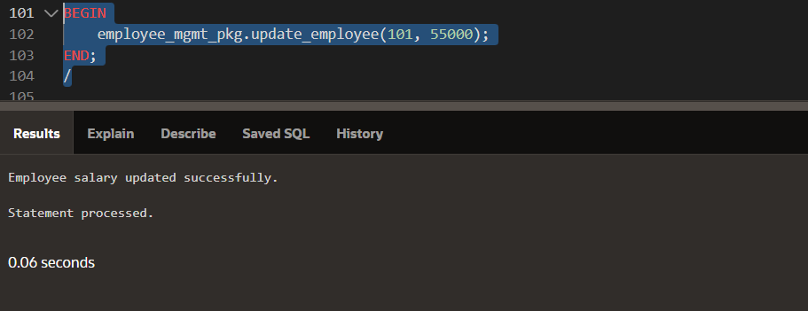

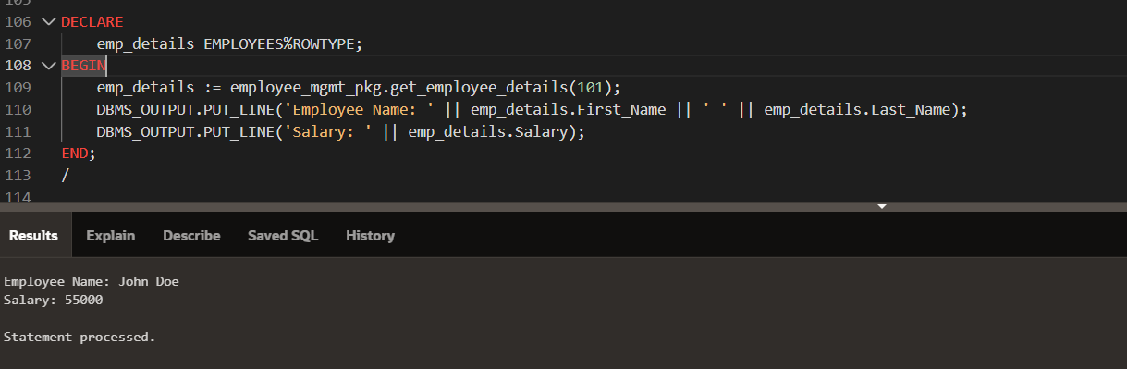

**Question-14**

__________________________________________________

CREATE TABLE ORDERS (

ORDER_ID NUMBER PRIMARY KEY,

CUSTOMER_ID NUMBER NOT NULL,

ORDER_DATE DATE NOT NULL

);

CREATE TABLE ORDER_LINES (

ORDER_LINE_ID NUMBER PRIMARY KEY,

ORDER_ID NUMBER NOT NULL,

PRODUCT_ID NUMBER NOT NULL,

QUANTITY NUMBER NOT NULL,

UNIT_PRICE NUMBER(10, 2) NOT NULL

);

-- Create the package specification

CREATE OR REPLACE PACKAGE order_mgmt AS

PROCEDURE create_order(

p_customer_id IN NUMBER,

p_order_date IN DATE,

p_order_items IN SYS_REFCURSOR

);

FUNCTION calculate_order_total(

p_order_id IN NUMBER

) RETURN NUMBER;

END order_mgmt;

/

-- Create the package body

CREATE OR REPLACE PACKAGE BODY order_mgmt AS

-- Procedure to create a new order

PROCEDURE create_order(

p_customer_id IN NUMBER,

p_order_date IN DATE,

p_order_items IN SYS_REFCURSOR

) IS

v_order_id NUMBER;

v_product_id NUMBER;

v_quantity NUMBER;

v_unit_price NUMBER;

v_order_line_id NUMBER := 1; -- Order Line ID counter

BEGIN

-- Generate a new order ID (using a sequence or max + 1)

SELECT NVL(MAX(ORDER_ID), 0) + 1 INTO v_order_id FROM ORDERS;

INSERT INTO ORDERS (ORDER_ID, CUSTOMER_ID, ORDER_DATE)

VALUES (v_order_id, p_customer_id, p_order_date);

LOOP

FETCH p_order_items INTO v_product_id, v_quantity, v_unit_price;

EXIT WHEN p_order_items%NOTFOUND;

INSERT INTO ORDER_LINES (ORDER_LINE_ID, ORDER_ID, PRODUCT_ID, QUANTITY, UNIT_PRICE)

VALUES (v_order_line_id, v_order_id, v_product_id, v_quantity, v_unit_price);

v_order_line_id := v_order_line_id + 1;

END LOOP;

COMMIT;

DBMS_OUTPUT.PUT_LINE('Order created successfully with Order ID: ' || v_order_id);

EXCEPTION

WHEN OTHERS THEN

ROLLBACK;

RAISE_APPLICATION_ERROR(-20001, 'Error occurred while creating the order: ' || SQLERRM);

END create_order;

FUNCTION calculate_order_total(

p_order_id IN NUMBER

) RETURN NUMBER IS

v_total_amount NUMBER := 0;

BEGIN

SELECT SUM(QUANTITY * UNIT_PRICE)

INTO v_total_amount

FROM ORDER_LINES

WHERE ORDER_ID = p_order_id;

RETURN NVL(v_total_amount, 0);

EXCEPTION

WHEN NO_DATA_FOUND THEN

RETURN 0;

WHEN OTHERS THEN

RAISE_APPLICATION_ERROR(-20002, 'Error calculating order total: ' || SQLERRM);

END calculate_order_total;

END order_mgmt;

/

-- USING THE FUNCTIONS

DECLARE

v_order_items SYS_REFCURSOR;

BEGIN

-- Open a cursor with order items data

OPEN v_order_items FOR

SELECT 101 AS PRODUCT_ID, 2 AS QUANTITY, 50 AS UNIT_PRICE FROM DUAL

UNION ALL

SELECT 102, 1, 100 FROM DUAL;

-- Call the create_order procedure

order_mgmt.create_order(

p_customer_id => 123,

p_order_date => SYSDATE,

p_order_items => v_order_items

);

END;

/

DECLARE

v_total NUMBER;

BEGIN

v_total := order_mgmt.calculate_order_total(1);

DBMS_OUTPUT.PUT_LINE('Total Order Amount: ' || v_total);

END;

/

Orders

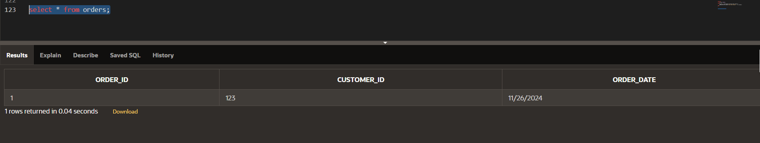

Order_Lines

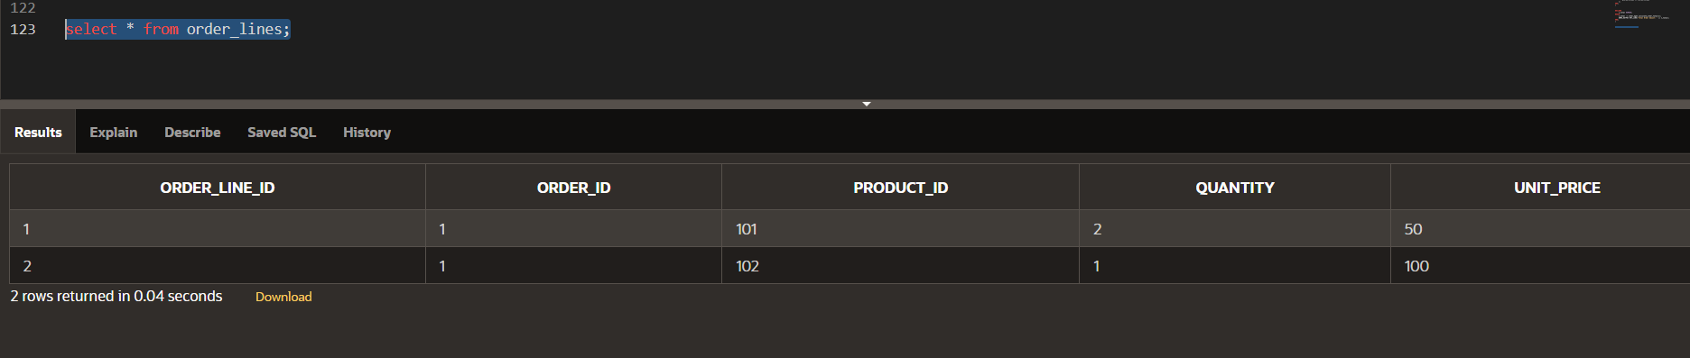

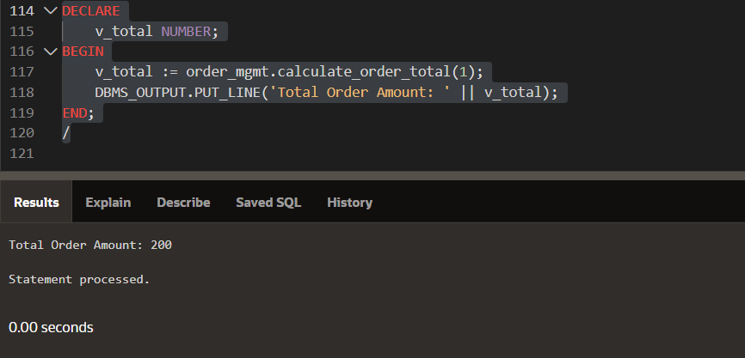

**Question-15**

__________________________________________________

CREATE OR REPLACE FUNCTION Employee_Salary_Trigger()

RETURNS TRIGGER AS $$

DECLARE

min_salary NUMERIC := 25000;

BEGIN

IF NEW.Salary < min_salary THEN

RAISE EXCEPTION 'New salary cannot be less than the minimum salary threshold!';

ELSE

IF TG_OP = 'INSERT' THEN

INSERT INTO Employees_Audit (

Employee_id, Operation, Change_date,

Old_name, Old_position, Old_salary,

New_name, New_position, New_salary

) VALUES (

NEW.Employee_id,

TG_OP,

CURRENT_DATE,

NULL, NULL, NULL,

NEW.Name, NEW.Position, NEW.Salary

);

ELSIF TG_OP = 'UPDATE' THEN

INSERT INTO Employees_Audit (

Employee_id, Operation, Change_date,

Old_name, Old_position, Old_salary,

New_name, New_position, New_salary

) VALUES (

NEW.Employee_id,

TG_OP,

CURRENT_DATE,

OLD.Name, OLd.Position, OLD.Salary,

NEW.Name, NEW.Position, NEW.Salary

);

END IF;

END IF;

RETURN NEW;

END;

$$ LANGUAGE plpgsql;

UPDATE Employees SET Salary = 40000 WHERE employee_id = 2;

INSERT INTO Employees VALUES(4, 'Jake', 'IT', 200000);

select * from employees;

select * from employees_audit;

Employees

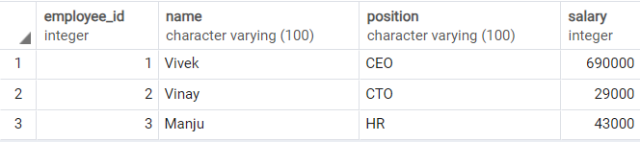

Employees_Audit

